**Abstract**

As Spatial Transcriptomics (ST) technologies have rapidly developed, so have related analysis methods such as identification of spatially variable gene (SVG), deconvolution and etc., Many methods have been developed and validated using simulated spatial transcriptomics datasets. However, current simulations are often performed by pooling pre-existing single cell data to synthesize a map with “bulk” samples as spots, reproducible and adjustable code/function to manifest different features of ST data is not available. Here, we present the Simulator of Spatial Resolved Transcriptomics Data (SoST) for reproducible and customizable simulation of spatially resolved data. Based on gamma-Poisson distribution and adjustable geometric patterns, SoST is able to simulate spatially variable gene in terms of one gene (on both spot and cell level) and mimic spatially resolved data with multiple cell types and genes.

**Key words:** Simulator of spatially resolved transcriptomics data, Spatially variable gene, Multiple cell type, Reproducible function, gamma-Poisson distribution, adjustable geometric patterns.

**Introduction**

Traditional RNA sequencing approaches such as scRNA-seq technology, provide quantitative information of single cells on gene expression but fail to take spatial information into account. However, spatially resolved transcriptomics technologies, unlike single-cell sequencing, are able to provide information of single-cell heterogeneity and identify cell types while retaining information on spatial context at the same time, which allows us to understand key properties of tumor biology, cell biology and neurobiology.

For example, we can better understand molecular behaviors of single cells contained in multicellular tissue if their physical locations can be learned. It is because cells in distinct regions or microenvironments within the same tissue could differentially express a set of genes since cells have influences on and also are affected by cells in their neighborhood. The consideration of the importance of spatial context and physical position of spot/single-cell level features, usually lost in scRNA-seq and bulk data, address the technological advantage in spatial transcriptomics [1].

As ST data have become available and popular, new methods thrive and attempt to unlock its potential. The concern of these methods is different from those designed and applied for analysis of scRNA-seq data. In a single cell experiment, the gene expression profile of cells is known, and a common task is to assign cells to groups(clustering) and then apply tests for differentially expressed gene. In contrast, ST dataset either don’t have information of individuals cells due to its lack of resolution (i.e., 10x Visium) or can’t cover every location/spot (each usually contains 10-100 cells) in one tissue (i.e., seqFISH, seqFISH+). [1]

Majority of existing analysis methods for ST data concentrate on these aspects: 1. Identification of spatially variable gene. This object is taken by tools such as SpatialDE, Trendsceek and Spark [2][3][4]. 2. Deconvoluting spatial transcriptomics spots to infer the proportion of cell types within them. This object is taken by tools such as RCTD, SPOTlight, Tangram and cell2location [5][6][7]. However, currently we don’t have mature ST datasets with both high resolution and throughput to test the performance of methods on ST data. In other words, ground truth of ST data is needed to test whether an analysis method can work well or compare two methods.

In this situation, another common way to test the performance of methods is through a simulated dataset. The major advantage of evaluating methods with simulated datasets is that different features, parameters and assumptions can be generated at low cost. It can be also observed that most spatial transcriptomics analysis packages are implemented and tested through simulation to address their effectiveness. However, simulation data are always specifically designed for individual methods. In this case, A reproducible and adjustable simulation framework to meet different research interests is needed.

In this project we present SoST, a reusable R function for simulation of spatially resolved transcriptomics data. SoST is a simulation framework allowing researchers to efficiently simulate ST dataset in a reproducible way. The simulated data is able to provide information of one/multiple gene expression counts of spots or single-cells, cell abundance(number) and cell proportion of one/multiple cell types.

**Spatially Variable Gene**

A gene is declared spatially variable if an observable change or difference in expression levels or counts between different spatial locations is statistically significant. However, in ST data, gene expressing differentially in different spots possibly reflect patterns, which can be attributed from heterogeneous distribution of cell number or proportion. These factors can confound the association between gene expression and spatial location, since cell number/proportion of one/multiple cell types can be associated with both spatial location and gene expression. For example, a gene actually is not highly expressed in cells within a spot. However, due to aggregation of a large number of cells normally expressing the gene or large proportion of some specific cell types highly expressing the gene, the total gene expression counts of that spot is high. In this case, we call the spatial pattern which is not only associated with spatial locations as a pseudo-spatial pattern.

**Results**

**The SoST Framework**

SoST implements six simulation models including Splat [8], a simulation model for scRNA-seq data. Four simulation models are aimed at simulating spatially variable gene on spot level and single-cell level in different scenarios. Two models including Splat are aimed at simulating spatially resolved data providing information of multiple cell types and multiple genes.

To simulate SVG, SoST used the parameters that can be customized by the user, to generate a SVG with three predefined geometric patterns: hotspot, linear gradient and streak. The main result of this simulation step is a matrix of counts where each entry is the total gene expression counts of all cells within the spot. The notation of spatial location of the result matrix is the same as that of ST data. For example, the entry in the $i^{th}$ row and $j^{th}$ column of the $m×n$ result matrix represents the sum of gene expression counts of all cells within the spot, whose spatial location is $i^{th}$ row and $j^{th}$ column on the real tissue ( $m×n$ grids). SoST also allows users to simulate pseudo-spatial patterns by setting parameters to define cell abundance and cell proportion. The results of pseudo-spatial pattern simulation provide information of single cells contained in spots.

To simulate ST data with multiple genes and multiple cell types, SoST allows users to simulate realistic scRNA-seq data by Splat [8] and allocate those simulated single cells to locations with different density. If no ideal scRNA-seq data can be used to simulate desired cells, a synthetic ST data can still be generated by our own simulation distribution model with adjustable parameters. The main result of this simulation step is a $m×n$ matrix where each entry represents cell-proportion of different cell types contained in the corresponded spatial spot. These simulations are described in more details in the following sections.

**Simulation Model for Spatially Variable Gene on Spot Level**

In this simulation model, gene expression counts of each spot (sum of gene counts of all cells within each spot) is modeled by negative binomial distribution. It allows to specify desired spatial patterns at spot level. Currently it has three predefined patterns: hotspot, linear gradient and streak. One gene is considered in this simulation model [2].

Notation (Input parameters that can be set by users are labeled as *customizable* at the end of explanation):

Let $l$ be length of pattern area. (customizable)

Let $L$ be length of background area. (customizable)

Let $(i, j)$ denote the spatial location of each spot. $i, j∈\{1, 2,…, L\}$

Let $\left(i^{*}, j^{*}\right)$, $\left(. , { j}^{*}\right)$ be the spatial location of the spot/column with highest or lowest expected gene counts. We will call that spot/column as index spot/column. (customizable)

Let $p$ be thickness of each geometric layer. (customizable)

Let $q$ be order of layer. For example, index spot is layer zero $q_{0}$; the adjacent layer of index spot is the first layer: $q=1$; the adjacent outer layer of the first layer is second layer: $q=2$.

Let $r$ be ratio of means of gene expression counts between two adjacent layers. $r$ can be either less or greater than 1. (customizable)

Let $Z_{\left(i,j\right),q}$ be random variable representing gene expression counts of the spot which belongs to layer $q$ and is located on $i^{th}$ row, $j^{th}$ column. ( $i$ and $j$ have different range depending on $q$.)

Let $μ_{q}$ be mean of gene expression counts of each spot in layer $q.$

Let $ϕ$ be dispersion parameter of negative binomial distribution followed by $Z_{\left(i,j\right),q}$. (This one and all dispersion parameter of different simulated distributions in following sections are customizable)

Let $μ_{q_{0}}$ be the mean of gene expression counts of index spot. (customizable)

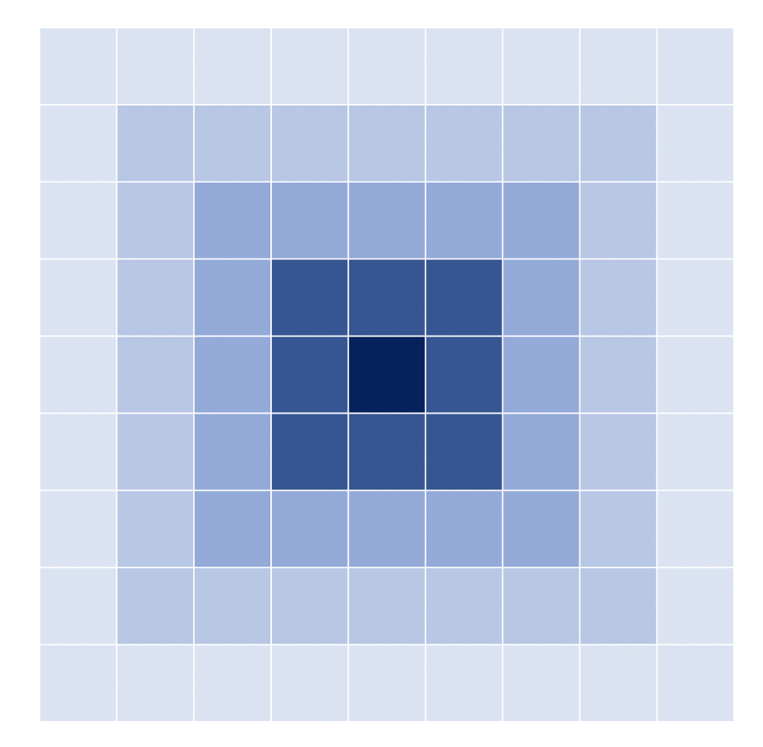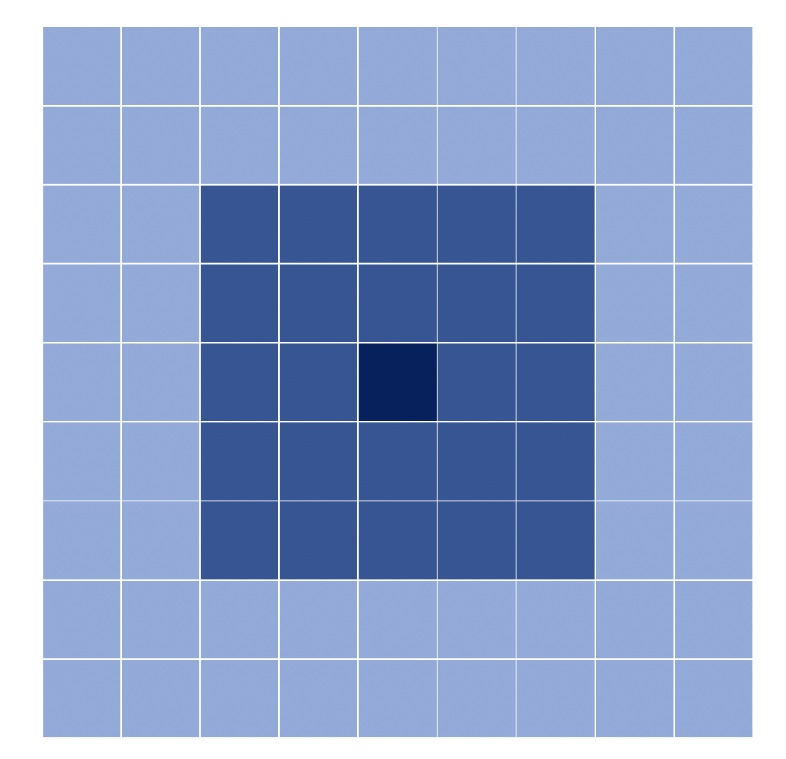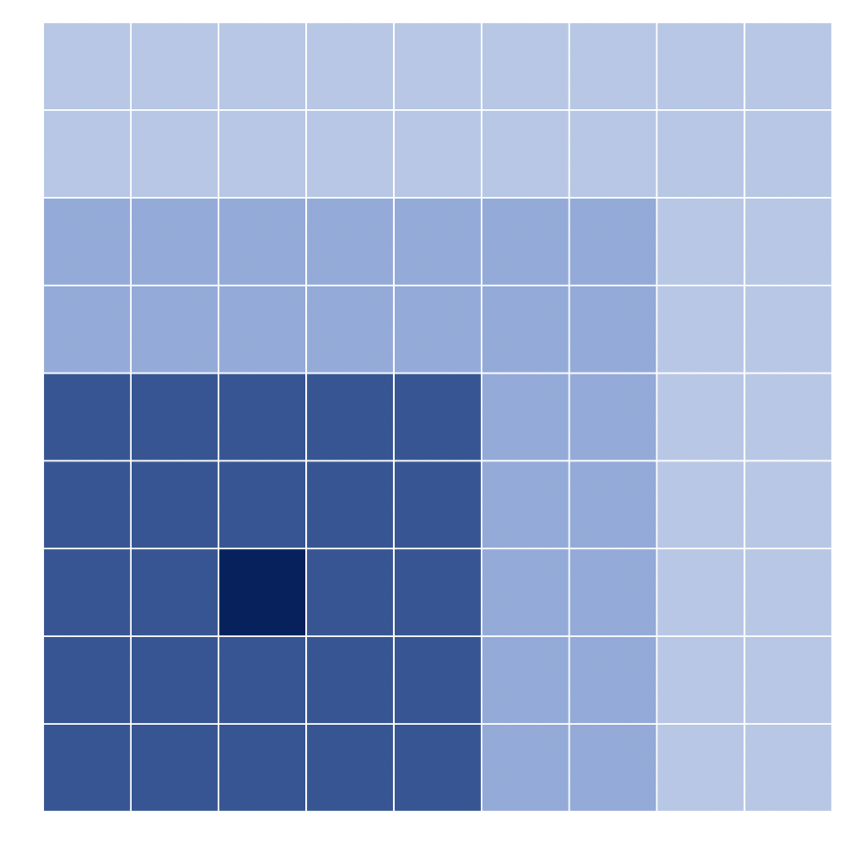

Figure 1: Explanation of parameters defining pattern’s geometric design. Pictures are labeled as A, B, C from left to right. The mean of gene counts of spots is higher in area with darker color.

1. Thickness of layer $p$ =1, Index spot’s location $(i^{*}, j^{*})$ = (5, 5), length of background area $L=9$
2. Thickness of layer $p$ =2, Index spot’s location $(i^{*}, j^{*})$ = (5, 5), length of background area $L=9$
3. Thickness of layer $p$ =2, Index spot’s location $(i^{*}, j^{*})$ = (3, 3), length of background area $L=9$

Distribution model for $Z_{\left(i,j\right),q}$:

$$Z_{\left(i,j\right),q} \sim NegativeBinomial (μ_{q}, ϕ)$$

In order to meet different desired geometric patterns (hotspot, linear gradient and streak) [2] numerical relationships between mean of gene expression counts of spots in layer zero and other layers are available to set.

For hotspot pattern:

Figure 2. Example output of hotspot spatial pattern on spot-level. Input parameters: coordinate of index spot $\left(i^{*}, j^{*}\right)=(20, 35)$, thickness of layer $p=2$, ratio of p $r=1.1$, expected gene counts on index spot $μ_{q_{0}}=200,$ length of square pattern area $l=60,$ length of whole picture $L=65$.

For linear gradient pattern, the relationship between different layer is defined in the same way. The only one difference is $q_{0}$: layer zero $q_{0}$ represents a spot in hotspot design but a column in linear gradient design.

Figure 3. Example output of linear gradient pattern on spot-level. Input parameters: location of index column $j^{*}=20$, thickness of layer $p=1$, ratio of means of gene counts between two adjacent layers $r=1.05$, expected gene counts on index spot $μ_{q_{0}}=100,$ width of rectangular pattern area $l=40,$ length of whole picture $L=65$.

For streak pattern, a band containing several columns has a gene expression pattern whereas spots outside the band are treated as background spots. It offers the most basic scenario of SVG [3].

Figure 4. Example output of streak pattern on spot-level. Input parameters: index band location column $y_{1}=10 to$ column $y_{2}=20$, expected gene counts $μ_{q_{0}}=100$ of spots in index band, expected gene counts $μ^{'}=50$ of spots in area out of index band, length of whole picture $L=65$.

The result of this simulation model represents gene expression spatial pattern on spot level. If the gene expression counts of one spot is high, it merely indicates the sum of gene counts of all cells within that spot is high. In other words, it conceals the information about single cells within spots.

**Simulation Models for Spatially Variable Gene at Single-cell Level**

Spatial gene pattern at spot level may be not only associated with spatial location. To be specific, information of cells such as cell abundance or proportion of one or more cell types within a spot can contribute to high gene expression counts. Hence, simulation models for SVG at single-cell level should take those confounders into account. To achieve this, we consider three scenarios to simulate SVG on single-cell level: 1. Spatial pattern driven by spatial location. 2. Spatial pattern driven by cell abundance which is associated with spatial location. 3.Spatial pattern driven by cell proportion which is associated with cell types and spatial location.

**Scenario 1: Spatial Pattern Driven by Spatial Location**

In this scenario, cells ins spots with higher gene expression counts have higher average gene expression. The gene spatial pattern is purely driven by spatial location.

Notation (omit notations with same meaning as before):

Let $t$ be the index of individual cells in the spot. Let $t_{\left(i,j\right),q}$ rec $(i, j)$ spot of layer $q$. Then $t∈\{1, 2, …, t_{\left(i,j\right),q}\}$ For example, if spot located at (1, 2) in layer $3$ contains 10 cells, then $t_{\left(1,2\right),3}=10,t∈\{1, 2, ..., 10\}$.

Let $T_{\left(i, j\right),q}$ be random variable representing cell number in $\left(i, j\right)$ spot belonging to layer $q$.

Let $Y_{\left(i, j\right),t,q}$ be random variable representing gene expression counts of cell $t$ in $\left(i, j\right)$ spot belonging to layer $q$. (range of $t$ depends on $i$ and $j)$

Let $Λ_{q}$ be mean of gene counts of each cell in spots belonging to layer $q$.

Let $α_{q}$ be the shape parameter of gamma distribution followed by $Λ_{q}$.

Let $α_{q_{0}}$ be the shape parameter of gamma distribution followed by $Λ_{q_{0}}$, the expected counts of cells in index spot $\left(i^{*}, j^{*}\right)$ belonging to layer zero $q_{0}.$ (customizable)

Distribution of cell number $T_{\left(i, j\right),q}:$

$$T_{\left(i, j\right),q} \sim Poisson(λ)$$

(Assuming that the expected number of cells in every cell is the same over all spatial locations.)

To account for extra Poisson variation of gene counts data, Poisson-gamma mixture is considered:

$Y_{\left(i, j\right),t,q} \sim Poisson (Λ_{q})$

$$Λ_{q} \sim Gamma (α_{q}, β)$$

Gene counts of a spot is summation of counts of all cells within that spot:

$$Z_{\left(i,j\right),q}=\sum_{t=1}^{t_{\left(i,j\right),q}}{Y_{\left(i, j\right),t,q}}$$

Numerical relationships between expected mean of gene expression counts of cells within spots in layer zero and layer $q$ is available to set:

$$α_{q}= r^{q}× α_{q_{0}}$$

(Hotspot pattern is applied in single-cell level pattern simulation.)

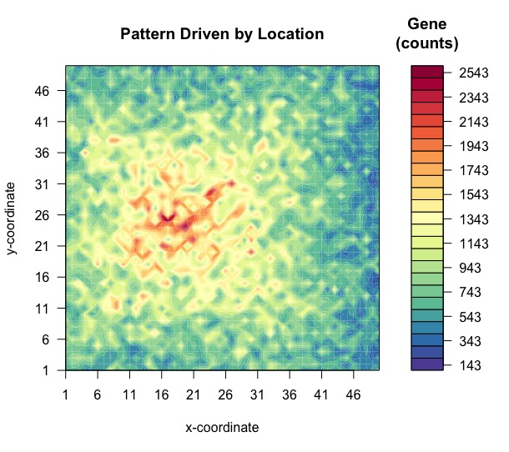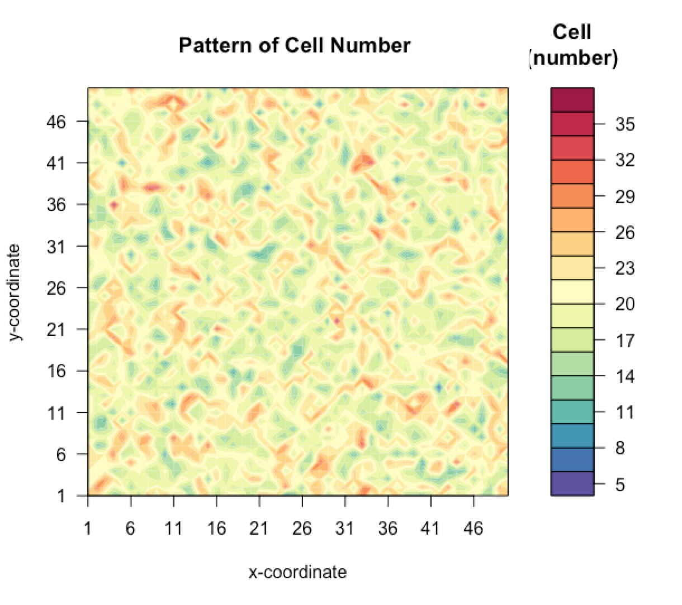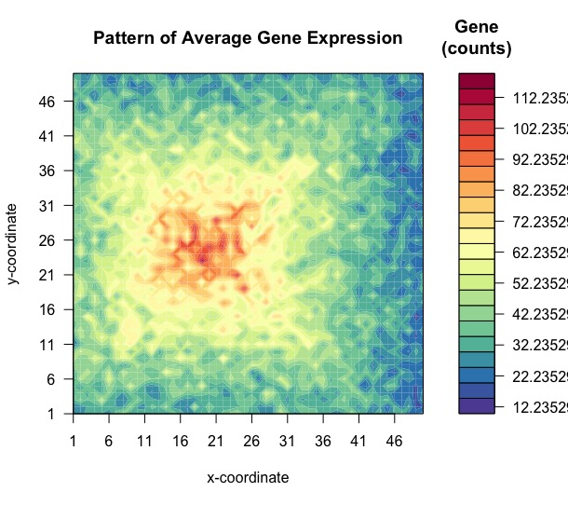

Figure 5: s

1. Observable spatial pattern on gene counts on spot level.
2. No pattern of distribution of cell number.
3. Observable spatial pattern on average gene expression counts. This simulation model generates a spatial pattern which is not pseudo-spatial pattern and driven by only spatial location.

The main result of this simulation is a matrix where each entry represents the average gene expression counts by summing up gene counts of all cells within every spot and then dividing them into simulated cell number. This is so called the spatial pattern on single-cell level. With summation of counts of cells within every spot, we are able to get the spatial pattern on spot level.

**Scenario 2: Spatial Pattern Driven by Cell Number**

In this scenario, Cells in spots with higher expression are denser in space so that those spots contain more cells, but gene expression is not highly variable across cells on different spatial locations. In other word, the spatial pattern on spot level is a pseudo-spatial pattern driven by cell number. There is an association between spatial location and cell number.

Notation:

Let ${ λ}_{q}$ be expected number of cells in spots belonging to layer $q.$

Let $λ_{q_{0}}$ be expected number of cells in spots belonging to layer $q_{0}.$ (customizable)

Distribution of cell number $T_{\left(i, j\right),q}:$

$$T_{\left(i, j\right),q} \sim Poisson(λ_{q})$$

Relationship no longer exists between mean of gene counts but cell number in spots belonging to layer zero and layer $q$:

$$λ_{q}= r^{q}×λ_{q_{0}}$$

Gene counts of cells across all locations follow the same distribution:

$$Y_{\left(i,j\right),t,q} \sim NegativeBinomial \left(μ, ϕ\right), for all possible i, j, t, q$$

Gene counts of a spot is summation of counts of all cells within that spot:

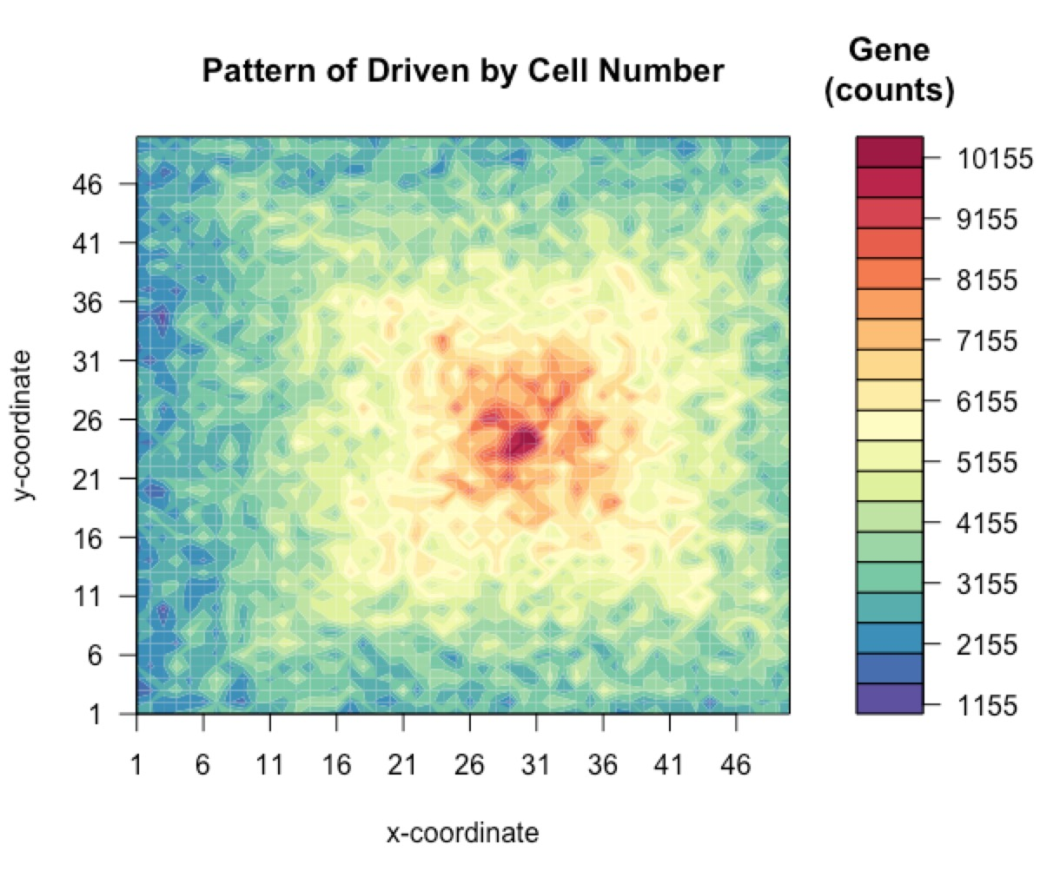 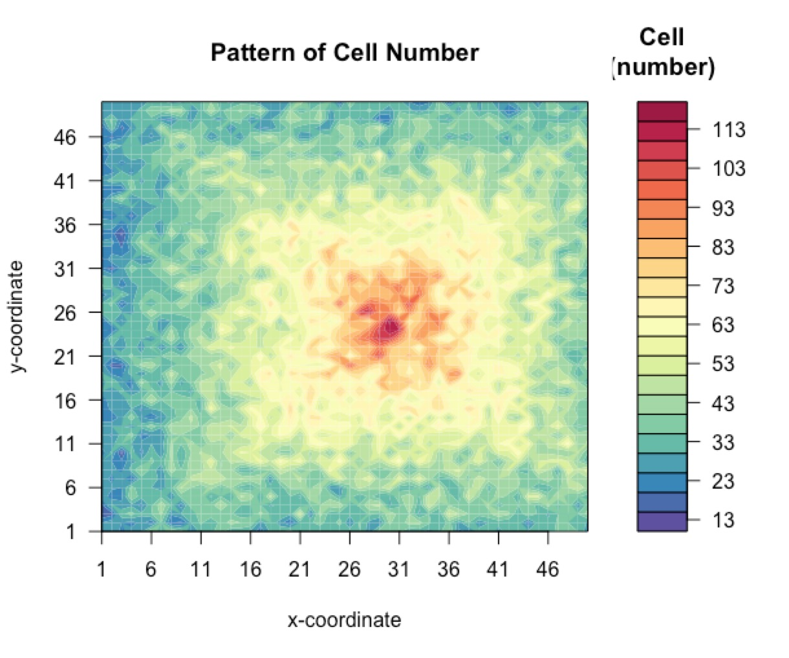

Figure 5: Example output of simulated hotspot spatial pattern driven by cell number (Pictures are labeled as A, B, C from left to right.)

1. Observable spatial pattern on gene counts on spot level.
2. Observable pattern of distribution of cell number.
3. No spatial pattern on average gene expression counts. In this scenario, we simulate a pseudo-spatial pattern driven by cell number associated with spatial location.

The main result of this simulation is a matrix where every entry represents the simulated cell number of every spot. We can get the spatial pattern on spot-level by summation of gene counts of cells across all locations. This simulation actually generates a pseudo-spatial pattern since it’s caused by cell number instead of highly variable gene expression of cells in those spots with high gene expression.

**Scenario 3: Spatial Pattern Driven by Cell Proportion**

In this scenario, more than one cell type is considered. The target gene is highly expressed in one cell type but not others. Some spots have a higher proportion of those cells that highly express the gene, and those spots observe a spatial pattern. Therefore, the spatial pattern is driven by cell type proportion and there is an association between cell type and cell location, and between cell type and average expression.

Notation:

Let $k$ indicate cell type $.$ $k∈\{k_{1}, k_{2}\}$. (two cell types are considered)

Let $R_{\left(i,j\right),k,q}$ be proportion of cell type $k$ in $\left(i, j\right)$ spot belonging to layer $q.$

Let $s$ be ratio of cell proportion of cell type $k_{1}$ of each pair of spots between two adjacent layers. (customizable)

Let $μ_{k}$ be mean of gene expression counts of individual cells belonging to cell type $k$. (customizable)

Let $Y_{\left(i,j\right),t,k,q}$ be random variable representing gene counts of individual cell $t$ of cell type $k$ in ( $i, j)$ spot belonging to layer $q$. $t∈\{1, 2, …, t_{\left(i,j\right),k,q}\}$

Let ${\overline{Y}}_{\left(i,j\right),k,q}$ be average gene count of cells of cell type $k$ in $\left(i,j\right)$ spot belonging to layer $q$.

Assuming that only cell type $k_{1}$ exists in index spot $(i^{*}, j^{*})$, pattern of $R_{\left(i,j\right),k,q}$ is defined as:

$$R_{\left(i,j\right),k_{1},q}=s^{q}×R_{\left(i^{*},j^{*}\right),k_{1},q_{0}}$$

$$R_{\left(i,j\right),k_{2},q}=1-R_{\left(i,j\right),k_{1},q}$$

$$R_{\left(i^{*},j^{*}\right),k_{1},q_{0}}=1$$

Assuming that cell number across all spots have the same mean, distribution of cell number $T_{\left(i, j\right),q}$ at $\left(i, j\right)$ spot in layer $q$ is modeled as:

$$T_{\left(i, j\right),q} \sim Poisson\left(λ\right) for all i, j, q$$

Distribution of gene counts $Y_{\left(i,j\right),t,k,q}$ of individual cell $t$ of cell type $k$ in ( $i, j)$ spot and layer $q$ is modeled as:

$$Y_{\left(i,j\right),t,k_{1},q} \sim NegativeBinomial \left(μ_{k_{1}}, ϕ\right),$$

$$Y_{\left(i,j\right),t,k_{2},q} \sim NegativeBinomial \left(μ_{k_{2}}, ϕ\right),$$

where $μ_{k_{1}}>μ_{k_{2}}$.

Then gene counts $Z_{\left(i,j\right),q}$ of $(i, j)$ spot in layer $q$ can calculated as:

Figure 6: Example output of simulated hotspot spatial pattern driven by cell proportion (Pictures are labeled as A, B from left to right.)

1. Observable spatial pattern on gene counts on spot level.
2. Observable spatial pattern on cell type proportion. In this scenario, we simulate a pseudo-spatial pattern driven by cell proportion associated with spatial location.

In this way, we can define a map with observable spatial gene pattern on spot level but no pattern on average gene expression of each cell type, since the expected gene counts of cell type $k_{1} and k_{2}$ are fixed. So, the simulated spatial pattern on spot level is a pseudo-spatial pattern. Besides, the pattern of cell proportion across spots can be observed and is similar to spot-level spatial gene pattern. The main results are two matrices: 1. A matrix where every entry represents total gene counts of the corresponding spot. 2. A data frame that contains information about cell proportion of two cell types on every spot.

**Simulation Models for ST Data with Multiple Cell Types and Multiple Genes**

Besides simulating individual SVG in different scenarios, SoST takes gene-gene correlation into account and provides a framework to generate ST data considering multiple cell types and genes.[9] This simulation process consists of two steps. The first step is simulating scRNA-seq data with two options: 1. Not a real-data based simulation model. 2. Real-data based simulation conducted by Splat [8], a scRNA-seq data simulator. The second step is to allocate generated single-cell data on spatial locations with densities. Distribution model of location and cell density is simulated based on our own models.

**Not Real-data Based Simulation Model of scRNA-seq Data:**

Notation:

Let $M_{k}$ be $n×1$ vector representing expected count of $n$ genes in cell type $k$. $M_{ki}$ is $i^{th}$ term in $M_{k}$ and represent expected count of gene $i$ in cell type $k$. $i∈\{1, 2, …, n\}$ (customizable)

Let $Σ_{k}$ be $n×n$ covariance matrix of $n$ genes in cell type $k$. $k∈\{k_{1}, k_{2}, k_{3}, k_{4}\}$, four cell types are considered. (customizable)

Let $Y_{k,i,t}$ be random variable representing expression count of gene $i$ in cell $t$ of cell type $k$.

The distributions of $M_{k} and Y_{k,i,t}$ are modeled as:

$$logM_{k} \sim MultivariateNormal \left(μ_{k}, Σ_{k}\right),$$

$Y_{k,i,t} \sim NegativeBinomial(M_{ki}, ϕ_{ki}$)

This simple model for simulating single-cell RNA data allows users to efficiently generate scRNA-seq data by adjusting all those parameters. However, this naïve framework fails to catch some features of scRNA-seq data. Hence, Splat [8] is wrapped in SoST to simulate realistic scRNA-seq data.

**Real-data Based Simulation Model of scRNA-seq Data:**

Splat [8] simulation model captures most features observed in scRNA-seq data including zero-inflation, expression outlier gene, differential library size between cells, and mean-variance trend. It uses parametric distribution with parameters estimated from real data.

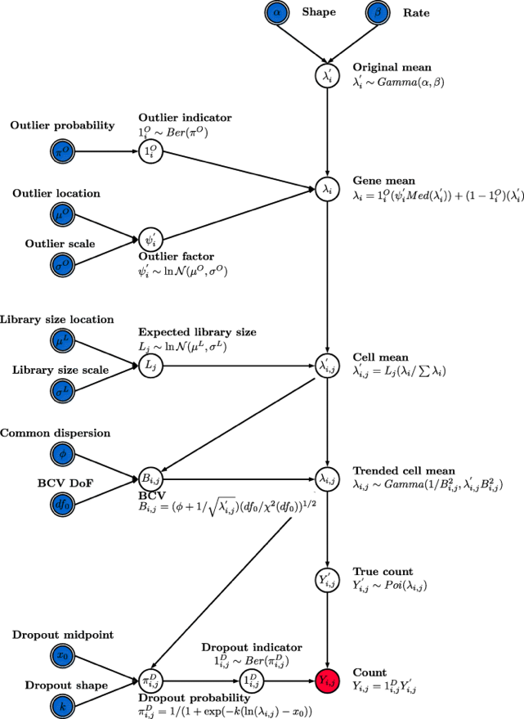

Figure 7: The Splat simulation model. Input parameters allowed to be defined by users are with double border. Input parameters which can be estimated from real scRNA-seq data are in blue*.* Output is shade red. The foundation of the Splat simulation is the gamma-Poisson model where the expected expression level for each gene 𝑖 (𝑖=1…, 𝑁) is simulated from a gamma distribution and the count for each cell 𝑗 ($j$ =1…, 𝑀) is sampled from a Poisson distribution, with correcting to include expression outliers, library size and mean-variance trend.

**Simulation Model for Spatial Locations and Density**

With simulated single-cell RNA data, the number of cell types within each spatial location are simulated based on different situations of sparsity and density.

Notation:

Let $N$ be random variable representing number of spots (locations) containing cells.

Let $D$ be mean of cell number.

Let $C$ be total number of spots in the background, which is a constant (customizable)

Two types of sparsity are modeled as:

$$Uniform:N \sim Gamma\left(μ=C×0.9, { σ}^{2}=\frac{μ}{0.3}\right)$$

$Sparse:N\sim$ $Gamma\left(μ=C×0.1, { σ}^{2}=\frac{μ}{0.3}\right)$

Cell number $T$ in those spots (locations) containing numbers is modeled as:

$$T \sim Poisson (D)$$

Two types of cell density are modeled as:

$$High density:D\sim Gamma \left(μ_{1}, σ^{2}=μ_{1}\right)$$

$$Low density:D\sim Gamma \left(μ_{2}, σ^{2}=μ_{2}\right),$$

where $μ_{1}>μ_{2}$.

For every cell type, $N$ locations are chosen from all $C$ locations by random. For each chosen location, cell number $T$ is simulated by sampling from Poisson distribution with rate parameter $D$. The cell number of other locations are 0. In default setting, $μ_{1}=2.5 and μ_{2}=0.8 [10]$.

At last, we can randomly allocate cells of each cell type to those simulated locations with designed density. The main result of this simulation is a data frame providing information about cell proportion and abundance on each spot (locations).

Figure 8: Example output of the simulation model using not-real-data based simulated single cell data. This map gives the distribution of each cell types, where cell type A is type of uniform sparsity and high density, cell type B is uniform sparsity and low density, cell type C is sparse with high density, cell type D is sparse with low density. Profile of gene expression of four cell types can also be derived but not shown here.

**Reference**

1. Eng, Chee-Huat Linus et al. “Transcriptome-scale super-resolved imaging in tissues by RNA seqFISH.” *Nature* vol. 568,7751 (2019): 235-239. doi:10.1038/s41586-019-1049-y
2. Svensson, Valentine et al. “SpatialDE: identification of spatially variable genes.” *Nature methods* vol. 15,5 (2018): 343-346. doi:10.1038/nmeth.4636
3. Sun, Shiquan et al. “Statistical analysis of spatial expression patterns for spatially resolved transcriptomic studies.” *Nature methods* vol. 17,2 (2020): 193-200. doi:10.1038/s41592-019-0701-7
4. Edsgärd, Daniel et al. “Identification of spatial expression trends in single-cell gene expression data.” *Nature methods* vol. 15,5 (2018): 339-342. doi:10.1038/nmeth.4634
5. Zhu, Qian et al. “Identification of spatially associated subpopulations by combining scRNA-seq and sequential fluorescence in situ hybridization data.” *Nature biotechnology*, 10.1038/nbt.4260. 29 Oct. 2018, doi:10.1038/nbt.4260
6. Cable, Dylan M et al. “Robust decomposition of cell type mixtures in spatial transcriptomics.” *Nature biotechnology*, 10.1038/s41587-021-00830-w. 18 Feb. 2021, doi:10.1038/s41587-021-00830-w
7. Dries, Ruben et al. “Giotto: a toolbox for integrative analysis and visualization of spatial expression data.” *Genome biology* vol. 22,1 78. 8 Mar. 2021, doi:10.1186/s13059-021-02286-2
8. Zappia, Luke et al. “Splatter: simulation of single-cell RNA sequencing data.” *Genome biology* vol. 18,1 174. 12 Sep. 2017, doi:10.1186/s13059-017-1305-0
9. Song, Qianqian, and Jing Su. “DSTG: deconvoluting spatial transcriptomics data through graph-based artificial intelligence.” *Briefings in bioinformatics*, bbaa414. 22 Jan. 2021, doi:10.1093/bib/bbaa414
10. Rodriques, Samuel G et al. “Slide-seq: A scalable technology for measuring genome-wide expression at high spatial resolution.” *Science (New York, N.Y.)* vol. 363,6434 (2019): 1463-1467. doi:10.1126/science.aaw1219